SIGNALS

GUIDE A HELICOPTER TO A LANDING POINT
071-334-4001

CONDITIONS

Given a prepared landing site for a UH-1 or UH-60 helicopter (the location of which is known to the pilot), individual TOE equipment, night vision goggles, FM radio (SINCGAR), and the appropriate arm-and-hand signals to guide the helicopter to the landing site and land the helicopter on the landing site.

STANDARDS

Guide the helicopter to a safe landing by MEDEVAC request, identifying the landing site to the pilot and controlling the landing using the correct arm-and-hand signals.

TRAINING AND EVALUATION
Training Information Outline

CAUTION
During training, dispose of all batteries IAW unit SOP.

1. As the aircraft approaches, provide the pilot with tactical and security information. Tell him of conditions that may affect his landing such as terrain, weather, landing site markings, and possible obstacles.
a. Confirm information or answer any questions the pilot may have pertaining to the landing site.
b. Maintain communications with the pilot during the entire operation.

2. Identify the landing site and guide the pilot in.
a. Once the pilot is within your area, he establishes radio contact with the unit for positive identification.
b. The pilot will be oriented to the landing site by using the clock method (12 o’clock is always the direction of flight). Tell the pilot the time position of your location. (For example: “The LZ is now at 3 o’clock to your position.”)
c. Mark or identify the landing site:
(1) Day—The only signals required are colored smoke and a signalman. VS-17 marker panels may be used to mark the landing site, but are NOT used any closer than 50 feet to the touchdown point. In addition to identifying the landing site, the colored smoke shows the pilot the wind direction and speed.
(2) Night—The landing site and touchdown point are marked by an inverted “Y” composed of four lights (Figure 1).

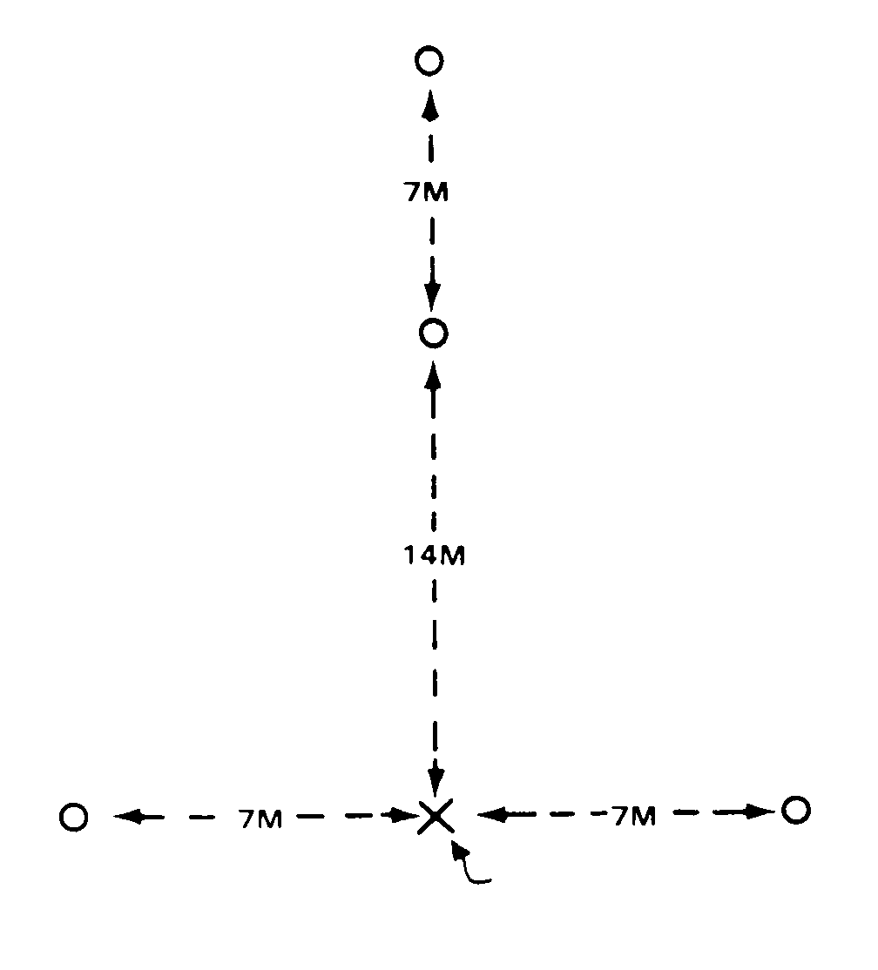
TOUCHDOWN
POINT

Figure 1. Night marking.

3. Use arm-and-hand signals (Figures 2 through 9).
a. The signalman’s position when directing a helicopter is to the right front of the aircraft where he can be seen best by the pilot. The signalman’s position for utility helicopters is 30 meters to the right front of the aircraft during day or night operations.
b. Signals at night are given using lighted batons or flashlights. In the illustrations, one of the men is using a lighted wand. This is a flashlight with a plastic wand attached to the end. The flashlight is used when visibility is decreased.
c. The speed of the arm movement indicates the desired speed of aircraft compliance with the signal.

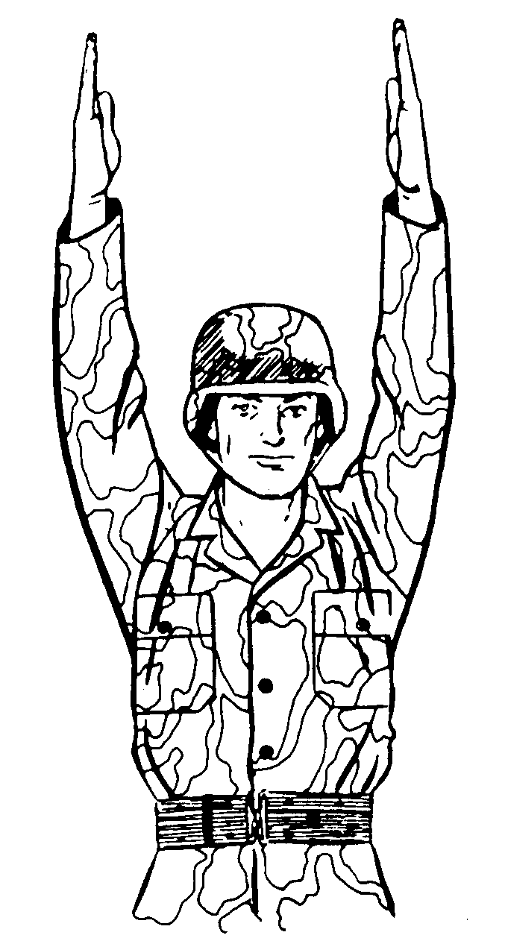

Figure 2. Arm guidance.

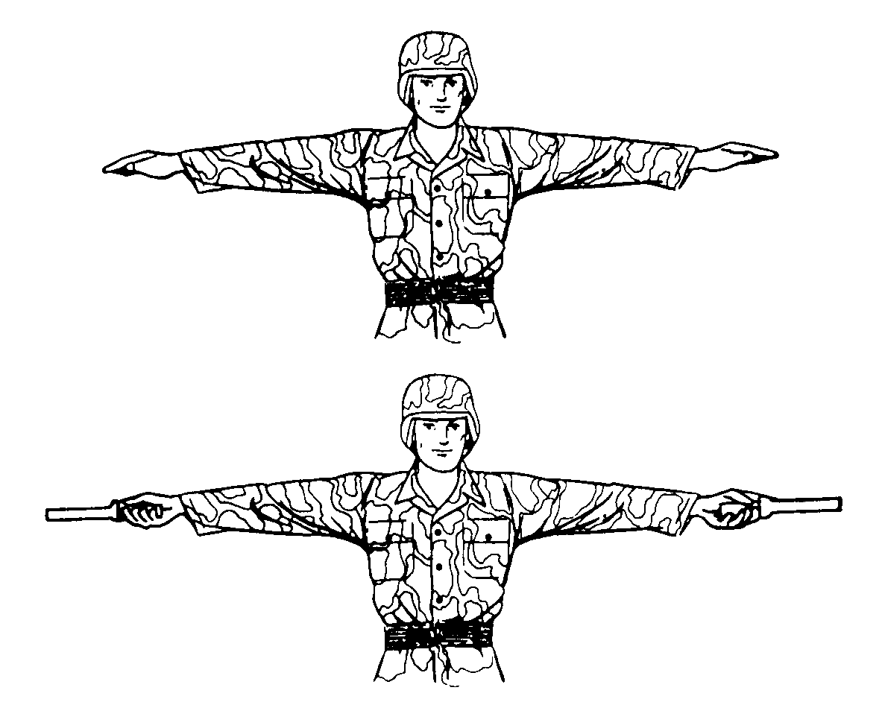

Figure 3. “Hover” signal.

Note: The “hover” signal should be used to change from one arm-and-hand signal to another. For example, assume that the signalman wants to land an approaching helicopter and has given the helicopter the “move ahead” signal. The helicopter is now positioned directly over the desired landing area. Before giving the helicopter the signal to move downward, the signalman should execute the “hover” signal. This gives the pilot time to change from the “move ahead” to the “move downward” signal.

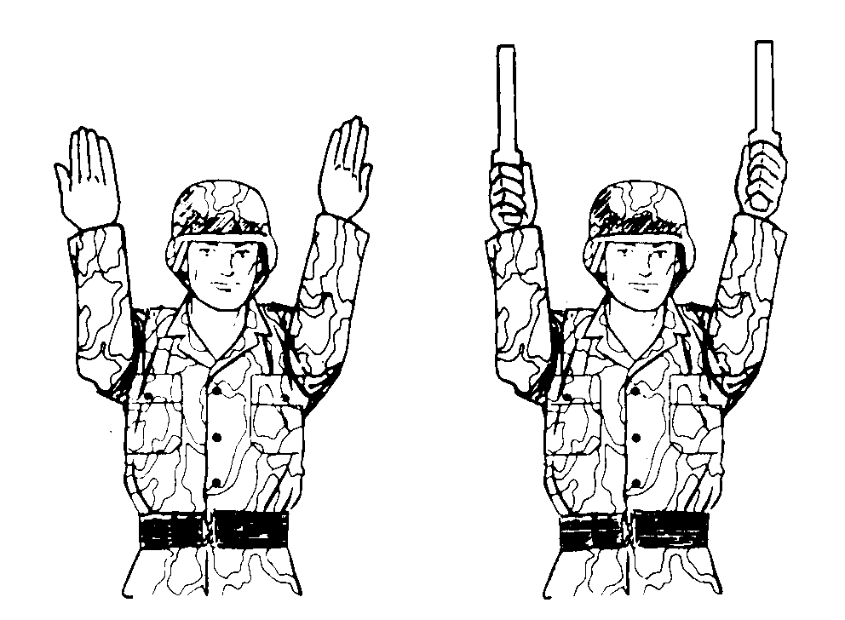

Figure 4. “Move ahead” signal.

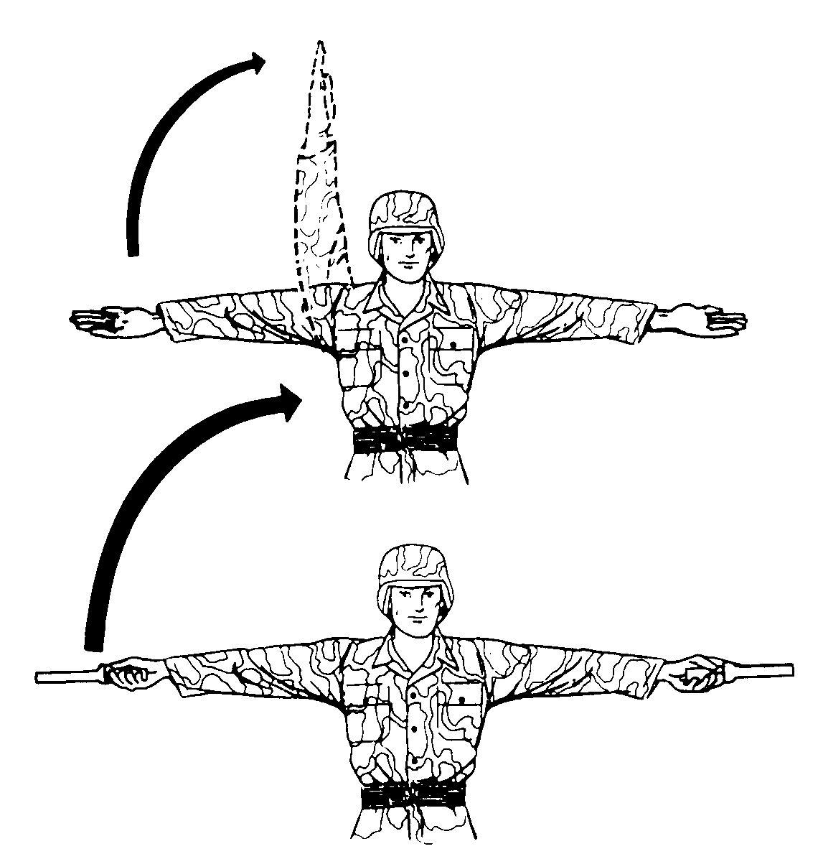

Figure 5. “Move to right” signal.

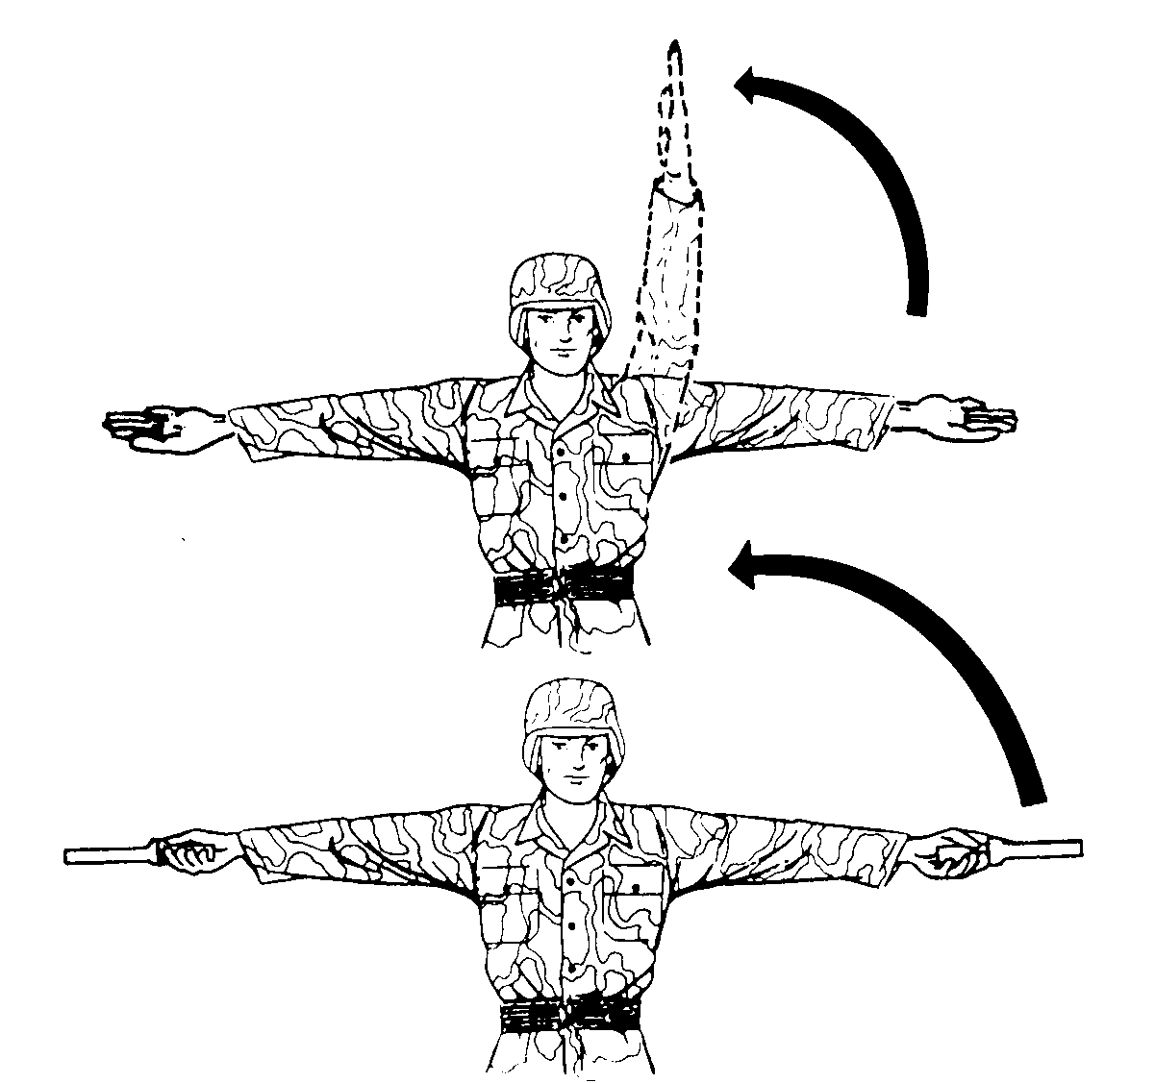

Figure 6. “Move to left” signal.

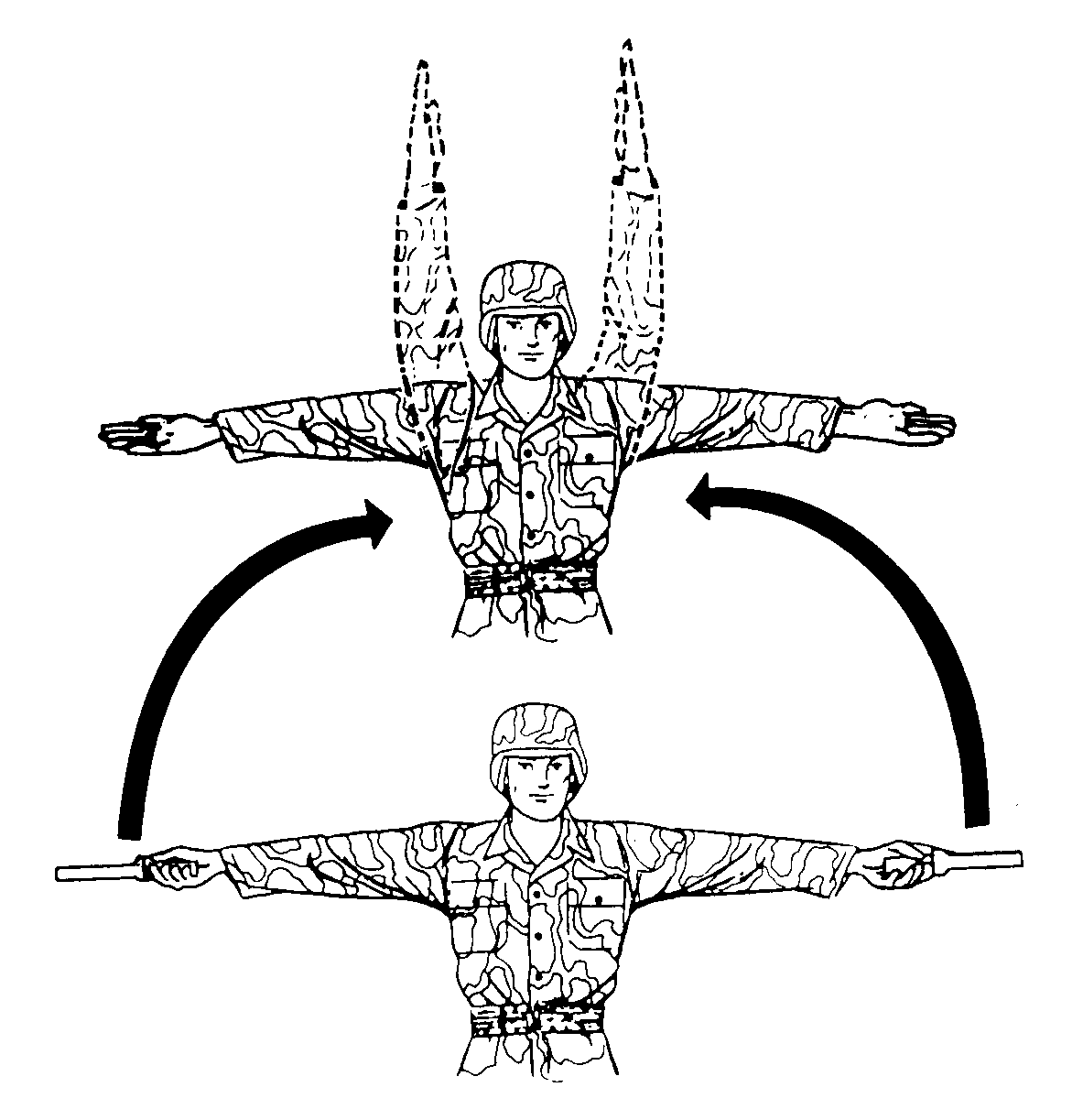

Figure 7. “Move upward” signal.

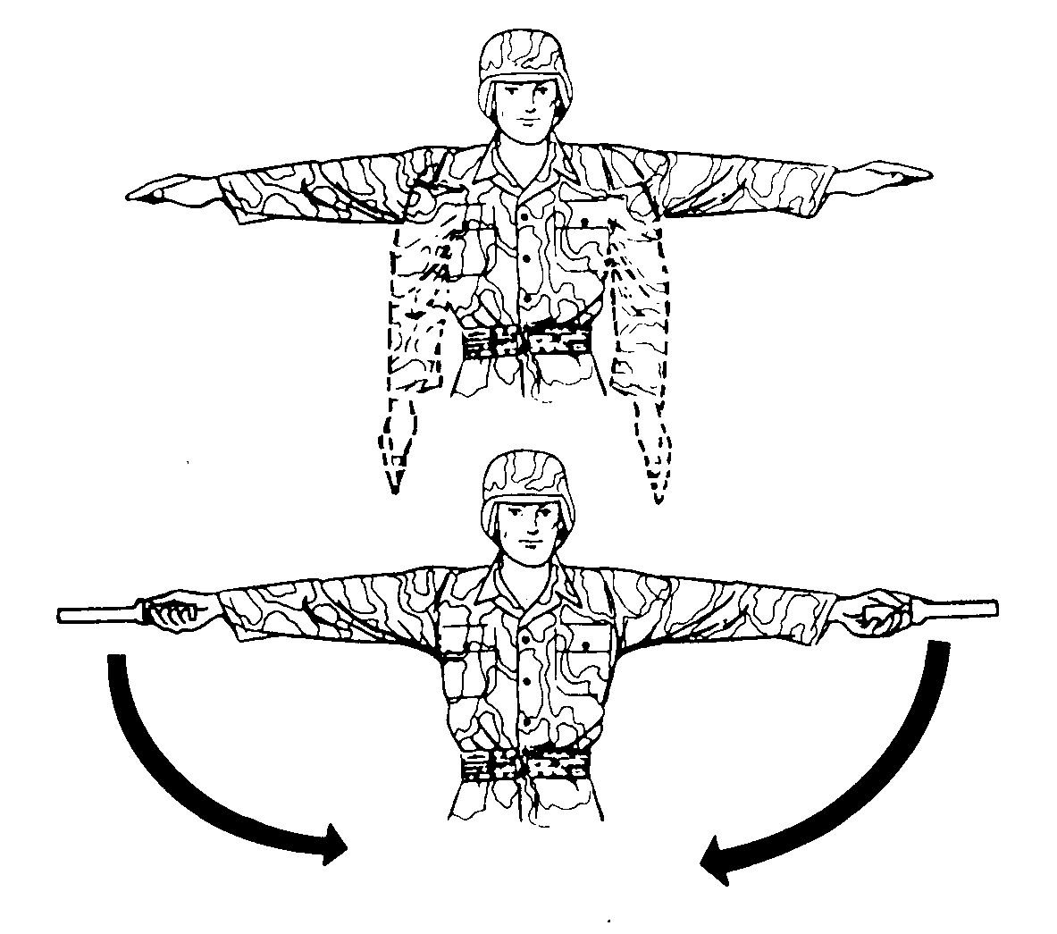

Figure 8. “Move downward” signal.

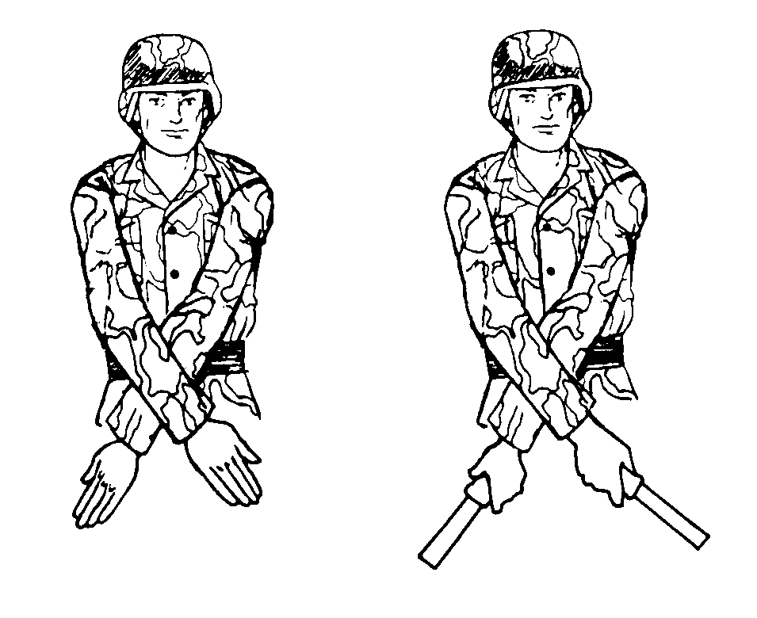

Figure 9. “Land” signal.

EVALUATION PREPARATION

Setup: At the test site, provide all equipment and information given in the task conditions statement. For test purposes, the tester may act as the pilot.

Brief Soldier: Tell the soldier that he is to land the helicopter using arm-and-hand signals.

EVALUATION GUIDE

Performance Measures Results

1. Advise the pilot of changes to the information given. P F

2. Identify the landing site to the pilot. P F

3. Control the landing using arm-and-hand signals. P F

FEEDBACK

Score the soldier GO if all steps are passed. Score the soldier NO-GO if any steps are failed. If the soldier fails any steps, show what was done wrong and how to do it correctly.

REFERENCES

Required Related
None FM 7-8
FM 21-60
FM 57-38

